**EXPERIMENT NO. 1**

**TO PERFORM POINT PROCESSING ON DIGITAL IMAGES**

**EXPERIMENT NO. 1**

**AIM:**  To perform point processing on digital images

**OBJECTIVES:**

1. To perform operations like digital negative and contrast stretching on digital images.

**EQUIPMENTS/SOFTWARE:** SCILAB

**THEORY:**

**Digital Negative:**

In many of the cases, the images that we get, they contain white or grey level information embedded in black pixels or very dark pixels and the nature of the information is such that we have very few white or gray level information present a white background which is very much dark. So, in such cases, finding out the information from the images, from the raw images, input images become very difficult.

*O*(*r*, *c*) = 255 − *I* (*r*, *c*)

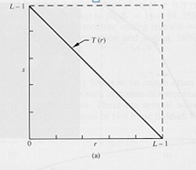

**Steps:**

1. Read the image.
2. Apply digital negative to image.
3. Display input and output images along with titles.

**Contrast Stretching:**

Contrast stretching is a simple image enhancement technique that attempts to improve the contrast in an image by `stretching' the range of intensity values it contains to span a desired range of values. **Contrast-Stretching** transformation that uses Piecewise Linear functions.

|  |  |
| --- | --- |
|  |  |

**Logarithmic Transformation**

Useful for enhancing details in the darker regions of the image at the expense of detail in the brighter regions.

Sometimes the dynamic range of a processed image far exceeds the capability of the display device, in which case only the brightest parts of the images are visible on the display screen. An effective way to compress the dynamic range of pixel values is to perform the following intensity transformation function:

s = c log(1+|r|)

where c is a scaling constant, and the logarithm function performs the desired dynamic compression.

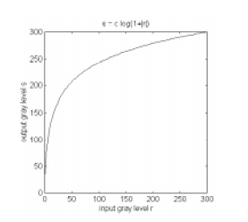

.

**ALGORITHM:**

1. Read an image.
2. Apply logarithmic function to the image using log10
3. Select the value of c.
4. Display input and output images along with titles.

**Digital Negative**

Code:

//Varad Patil 120A2036

//expt1 To perform operations like digital negative on digital image

close;

clear all;

img1 = imread('C:\Users\admin\Desktop\varad extc\cameraman.png');

[r, c] = size(img1)

g = rgb2gray(img1);

[row, col] = size(g);

for ia = 1:row

    for ja = 1:col

        b(ia,ja) =  255 - g(ia,ja);

     end;

end;

imshow(b);

**Output:**

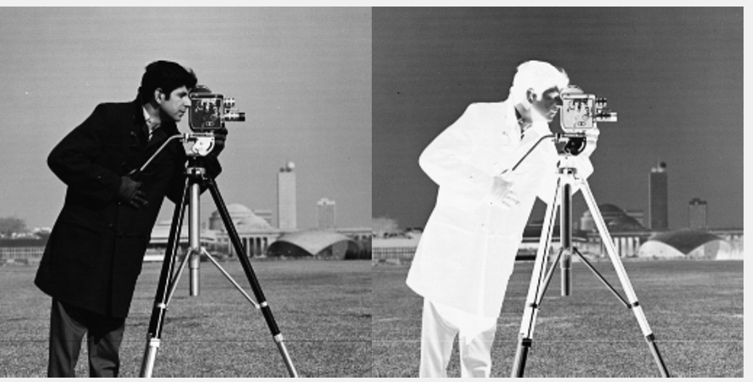

**Contrast Stretching:**

**Code:**

//expt1 to perform point processing technique on given image

// contrast stretching

//varad patil 120A2036

close;

clear all;

clc;

img = imread('C:\Users\admin\Desktop\varad extc\pout_img.png');

g = rgb2gray(img1);

[r, c] = size(g)

L = 256

s1 = 50

s2 = 170

r1 = 100 // r1>s1

r2 = 150 // s2>r2

m1 = s1/r1

m2 = (s2-s1)/(r2-r1)

m3 = (L-1-s2)/(L-1-r2)

for x =1:r

    for y = 1:c

        r = g(x,y);

        if r < r1 then

            s(x,y) =m1*r

        elseif r1<=r & r2 >= r then

            s(x,y) = m2*(r-r1)+s1

        else

            s(x,y) = m3*(r-r2)+s2

            end

end

end

img3 = [g s]

imshow(img3)

**Output:**

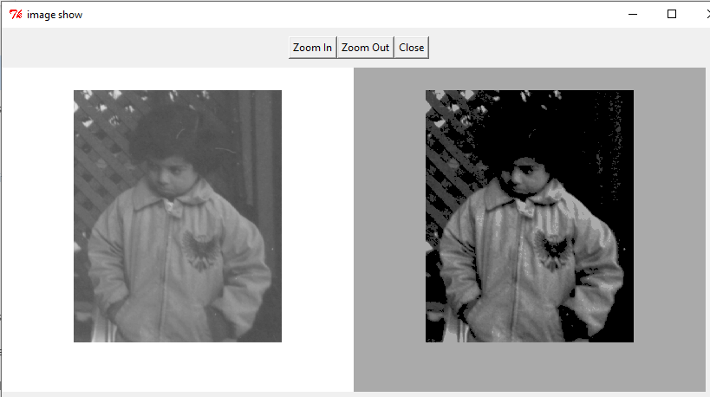

**CONCLUSION:**

**In this experiment, we are able to write code for digital negative and contrast stretching on digital images. We also learn about Converting RGB image to grayscale images, creating of matrix for digital negative, use of for loop, if else and image processing tools in scilab etc. Thus, point processing was performed successfully on digital images.**